Wycombe Wanderers Women - January 2022

- Our u18s are through to the FINAL of the Berks & Bucks u18s cup! They beat Winnersh Rangers 9-1. We will find out the opponents In due course and all information will be published on our social media.

- Wycombe Wanderers Trust are holding a quiz night on Friday 28th January at 7pm via zoom. All proceeds of this will be going towards our 3 women’s teams. There is a suggested donation of £5 per a team. To sign up, click: https://square.link/u/n4A8yYTd.

- Our reserve team were kindly invited to the Oxford United game to watch the men’s team. They cheered on the team to victory. Before the game, they spoke to Wycombe Sound and discussed the season so far. At half time they were presented on the pitch and given a round of applause from the crowd.

- Ambassador, Emily Isaac, is now a FSA member and will represent both WW Trust & WW Women on the Women’s game network.

- The reserves have started 2022 with a winning start as they put 6 goals past Launton Ladies. The first team haven’t pick up anymore points yet and next up they face Moneyfields. Our u18s are back in league action this weekend. Last time out, they won 12-0 to Winnersh Rangers (league game).

Upcoming Fixtures:

First team:
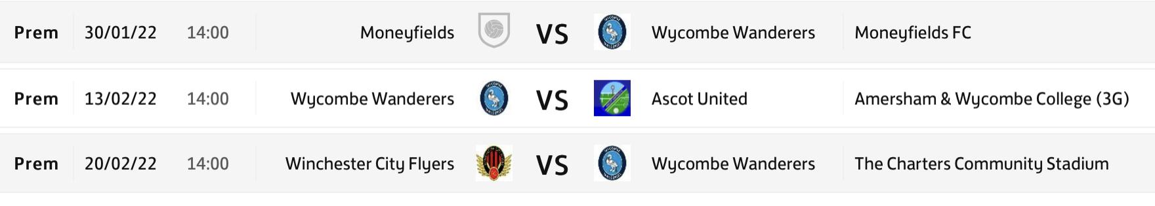
Reserves:
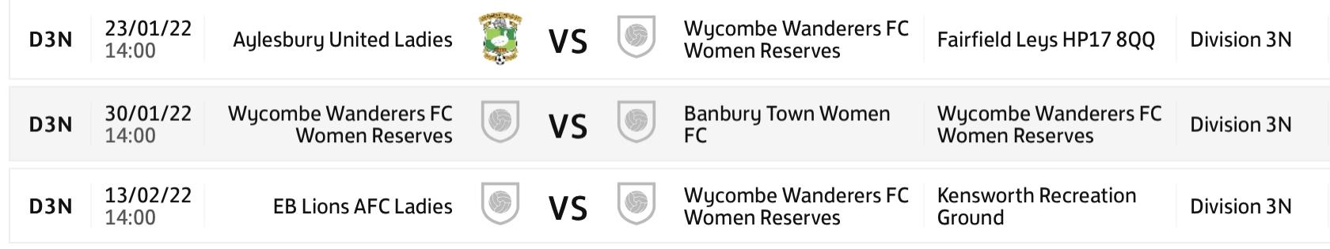u18s:
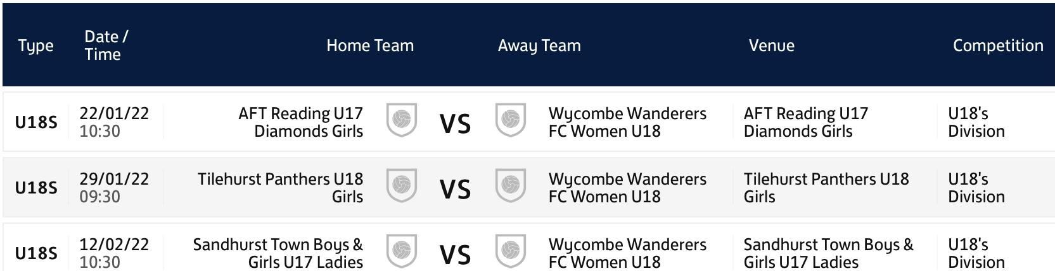

Emily Isaac 18.1.22

