Our mi MINUTES OF THE PUBLIC PART A OF THE TRUST BOARD MEETING HELD ON 29 SEPTEMBER 2022 at 7pm.

Present: Nigel Kingston (NK) Chairman of WWFC Trust Board (Chair)
Trevor Stroud (TS) Trust nominated member of the Football Club Board
Tony Hector (TH) Trust nominated member of the Football Club Board, Society Secretary
Alan Cecil (AC) FALL Director, Website, Twitter and Facebook supporter interaction
John Jewell (JJ) Fundraising
John Workman (JH) Marketing the Trust Leader
Lisa Bowker (LB) Assists with Volunteers/ Fundraising
Bob Massie (BM) Vice Chair, Communications, Fundraising and Commercial
Martyn Broughton (MB) Trust Treasurer, FALL Director
Chris Harvey (CH) FALL Director
Emily Isaac (EI) WWW Representative

Apologies: Russell Jones (RJ) Membership Secretary

Plus 10 Trust Members who joined the Zoom meeting and 10 Trust members present.

NK welcomed everyone to the meeting.

Items outstanding from last Meeting.

Disabled Supporters Association meeting held 31 August 2022 and officers were duly elected. Chairman Nigel Vickery, Secretary Peter Lerner, Liam O’Rourke Media and Communications, Claire McMackin Membership Secretary. Alexander Vickery will handle Away Coaches. Committee held its first meeting on 27 September.

Minutes of the previous meeting held on 25 August 2022 were unanimously agreed and NK signed them on behalf of the Trust Board.

Agenda:

Trust Fundraising Report: Circulated to Board and on Trust Website. JJ advised that best month ever as highest number of sales on QBC ball draw plus over £2k for Online Auction. This also included 2 rainbow shirts which raised £280 which will go to the charity next week. All items delivered.

WWFC Women: Circulated to Board and on Trust Website. EI advised Ladies are playing at Adams Park on Sunday 2nd October in FA Cup 2nd Round qualifying against Sport London E Benfica. Tickets £5 each and available to book on Club Ticket Site. Caledonian will be open before the game and seating in Origin Stand. Encourage all to come along.

WWSET Report: Was not circulated to Board or on Trust Website. Mark Gaitskell has taken over this week from Paul Foley so no report available. We will aim to reinstate monthly reports from October meeting.

Trust Finance Summary. Circulated to Board. Apologies not on website. Received £2100 from OWWSA to help with broadcasting equipment for matchdays. Holding until the Football Club have spent the money and request funding from Trust. Have deposited £85k with Redwood Bank and earning 1.3% interest which is much better than HSBC. Earning over £100 interest a month from these two accounts combined. During the month routine bank transfer went awry in Football Club and we assisted them with £19k which was paid back by 8th September 2022. £165k in bank and liabilities of £12000, made up of reserve for QBC bonus ball, Eid Ramadan Trophy grant, OWWSA Camera donation and a commitment of £5k donation to Womens Team over the year. £152k available to us not committed yet.

Disciplinary, General Meetings and Trust Board Meetings Policies: TH advised that we try to update the various policies on an annual or bi-annual basis depending on Football Supporters Association (FSA) guidance. Gone through General Meetings and Trust Board Meeting Policies and they still fall into the guidelines of the FSA. No changes need. Ask Board to confirm these and there were no objections.

Trust Rules Review: Need to be updated in line with change in circumstances and in line with recent guidelines published by FSA. Final draft on Website showing tracked document changes. Some parts will strengthen some of our safeguards but should not be anything contentious. If you have any comments or questions then the information is there to contact either TH or NK. Proposal will come back to the meeting in October for formal proposal and will be brought forward in November at the AGM for formal approval. Once approved by Trust members it will go back to the FSA, who will forward onto the Financial Conduct Authority for final approval. Independent sets of eyes will go through this to check for anomalies.

Trust AGM 17 November 2022: NK will send a save the date notification. 3 Directors will be retiring by rotation (Alan Cecil, Lisa Bowker and John Jewell). Any questions regarding persons wishing to put their name forward and would like some information please contact either NK or any member of the Trust Board.

Membership Renewal Update: RJ apologised as unable to attend meeting. All members should have received an email letting them know what they need to do to renew their membership. If not received please contact RJ. Please check your Spam emails. Some standing order members have changed to Go Cardless which is our preferred option for paying this membership. Most fall due in October and November. Nothing more to update at this time. Please try and recruit new members to join.

Programmes Proposal: JJ said that not yet in a position to put forward a proposal whether we go ahead with this. Original suggestion was that we produce 2 or 3 Trust programmes during the season. Made progress as Cambridge United (who already do this) have responded and JJ is having a phone call with them next week. Approached WWISC to see how they do The Wanderer. They use Beyond PU and waiting for costings Approached Phil Catchpole and others but if we are using any of their items we will need the Club’s approval to use them. Will need volunteers and time to put the programme together. JJ will have a recommendation by the next meeting. AC asked about possibility of selling them to hospitality etc.

Club Update: TH reported that at previous meeting there was a question regarding the use of glass glasses and whether to move to recyclable ones. The Club are looking into this and Heineken, as part of their corporate social sustainability are doing their bit for the environment have been sponsoring these and is being looked at by the Club. Issues with the toilets continue to be raised and is very high on the agenda but it is being progressed. Quite a lot of questions regarding energy and early kick offs. The EFL have not yet taken a position on this. However, numerous clubs have been looking at it. Lots to consider i.e. bring the game forward then how many Clubs will need to send players overnight and more hotel charges. Effect on supporters having to get there earlier. Taking children to morning activities and then coming to football may cause issues. High risk of losing supporters which may be counter-productive and there is not a lot of saving to be made. A number of referees still ask for lights to be put on even with early starts, the Club will have no option but to agree.

Fan-led Review – comments about what is going to happen and not happen. New government may not be as interested but new Minister met with F A and will be publishing a White Paper sometime this year. This will be sufficient to cover their obligation. No obligation in Government’s manifesto to actually implement the Review but just to look at it.

TS advised that we are talking to a local company, Whiffaway, who are keen to support the club and help upgrade Toilet facilities as they are local company. Proposal coming through next week and will need Board approval.

Going through a tough time on the pitch. Worst in recent history and mostly down to injuries and suspension. TS went to training ground last week at 5pm and the players were still there putting in a shift. Hang on and support the manager and team, as we will come out the other side.

Rob Couhig is due to come over soon and then there will be a Club Board Meeting. New owner at Derby was great when we visited the other week and were very hospitable and little issues with the fans.

Safeguarding: TS said safeguarding is high on agenda. We as a club have a good record except Barnardo’s said that our record keeping was poor. All professional clubs will be measured and rated either Gold, Silver or Bronze. All clubs need to be at Gold within 5 years and if not then will be fined. Trevor Stroud, David Cook, Tom Holder, Steve Copp and David Steele are the Safeguarding Committee. Stewards are being briefed and not only children but all vulnerable people are potentially at risk. Have EFL appointed adviser in place. Barnardo’s are coming again to look at improvements we have made from the original audit. WWFC aim is to be Gold within 3 years. Need Safeguarding Strategy in place which will need to go to the Board for approval. Notice that there are posters around the ground with phone numbers for contact. Originally 20% of those needing DBS had been completed but now there are 85%. Question raised about diversity of Safeguarding committee which is all male. TS will bring this up at the next meeting.

ANY OTHER BUSINESS:

- Tomorrow night is OWWSA quiz night and starts at 7.30pm in Caledonian. Prizes required
- 25 October set as Rainbow Laces day for WWFC. More information to follow.
- The Trust are proposing to purchase a Gazebo to cover the Trust table. Cost will be approx. £175. Need to check regarding safe exit from Caledonian before it is erected. Finance approved by board.
- Peter Lerner asked to say a few words about Box 1 project. There is a leaflet attached at the end of the minutes. Involves using Box 1 in Frank Adams Stand and will be supervised and equipped with sensory/calm room for supporters with autism, stress and anxiety together with their carers. Modelling on Sunderland’s very successful room and they have given us some very good advice. The space outside Box 1 will be changed into a platform for supporters with limited mobility with their carers. Cost should be approx. £20k. DSA is fundraising for this money. There is a GoFundMe page https://gofund.me/25238752. If you know anyone who is able to donate then please give them the link. Also looking for companies to assist with supporting the project. Looking for supporters who are builders and other professional people who will provide their services for free or low charge. Room conversion will need furniture and special lighting. Main work outside, remove seating, levelling off surface and putting in seating and spaces for wheelchairs.

The monies will go from the Go Fund Me to the Trust bank account.

QUESTIONS AND ANSWERS FROM TRUST MEMBERSHIP

Concerned about reusable plastic glasses rather than glass. Can they be used by people who have difficulty holding flimsy glasses. If it goes ahead then it will be rigid hard plastic glasses. The reason that we are being asked to look at it is regarding recycling. In outside areas cannot use glass and have to use plastic and these are just thrown away. Does not answer the long-term issue of recycling. Cricket and Rugby has successfully trialled this.

Money loaned to the Football Club did it have interest included. MB advised that it was only a few days and therefore not added.

QBC Draw: Record month for signups. Next month is looking good already. There are 925 balls in the bag tonight. Number 838 was drawn out. Sheila Boyce is the winner of £ 739.20. The bonus ball was not drawn and will roll over until next month.

Meeting finished at 8.07 pm.

Tina Davis
Trust Minute Taker for Part A.

WYCOMBE WANDERERS DISABLED SUPPORTERS’ ASSOCIATION
BOX 1 PROJECT
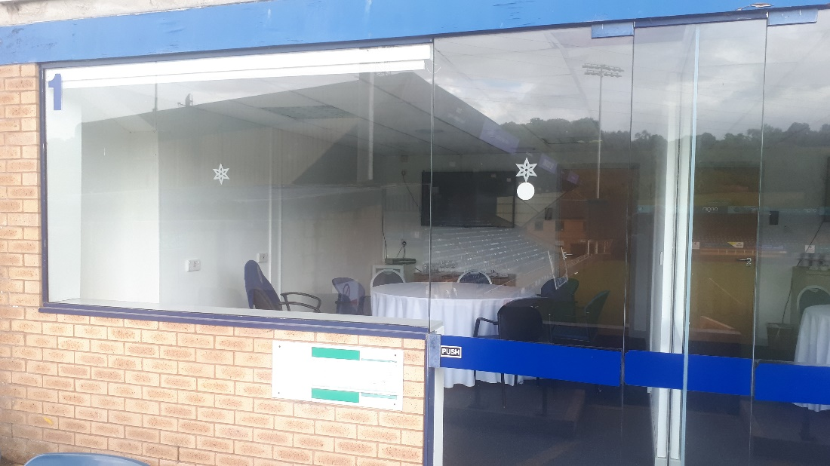

- Convert interior of Box into a supervised and equipped Sensory / Calm Room for supporters with autism, stress, anxiety, together with carers
2. Convert exterior seating into a platform for supporters with limited mobility

Cost: < £20,000
We are seeking:
Donations – via Gee Grou’s GoFundMe page https://gofund.me/25238752
Grants - suggestions for funding sources gratefully received
Philanthropists and Company Donations
Gifts in Kind – do we have builders / contractors in our membership who could undertake the external works for free in return for naming rights / logo?
Let’s demonstrate that WWFC really is a community Club!

WWFC DSA Committee: dsa@wwfc.com

